**DMAIC**

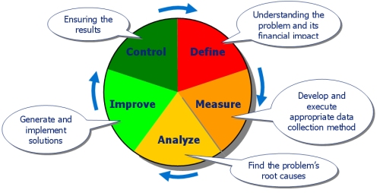

**Define**

|  |  |
| --- | --- |
| **Goals** | The purpose of this step is to clearly articulate (rõ ràng) the business problem, goal, potential (tiềm năng) resources, project scope and high-level project timeline. This information is typically captured (nắm bắt được) within project charter document. Write down what you currently know. Seek to clarify facts (làm sang tỏ vấn đề), set objectives and form the project team. |
| **Output** | * + - A clear statement of the intended improvement and how it is to be measured     - A high-level map of the process     - A list of what is important to the customer |
| **Do** | * + - Define customer requirements as they relate to this project. Explicit customer requirements are called Critical-to-Quality (CTQ) characteristics;     - Develop defect definitions as precisely as possible;     - Perform a baseline study (a general measure of the level of performance before the improvement project commences)     - Create a team charter and Champion;     - Estimate the financial impact of the problem     - Obtain senior management approval of the project |

**Measure**

|  |  |
| --- | --- |
| **Goals** | The purpose of the Measure phase is to fully understand the current performance by identifying how to best measure current performance and to start measuring it. The measurements used should be useful and relevant to identifying and measuring the source of variation (nguồn gốc sự biến đổi)**.** Focus the improvement effort by gathering information on the current situation |
| **Output** | * + - Data that pinpoints problem location or occurrence     - Baseline data on current process sigma     - A more focused problem statement |
| **Do** | * + - Identify the specific performance requirements of relevant Critical-to-Quality (CTQ) characteristics     - Map relevant processes with identified Inputs and Outputs so that at each process step, the relevant Outputs and all the potential Inputs (X) that might impact each Output are connected to each other     - Generate list of potential measurements     - Analyze measurement system capability and establish process capability baseline     - Identify where errors in measurements can occur     - Start measuring the inputs, processes and outputs and collecting the data     - Validate that the problem exists based on the measurements     - Refine the problem or objective (from the Analysis phase) |

**Analyze**

|  |  |
| --- | --- |
| **Goals** | In the Analyze phase, the measurements collected in the Measure phase are analyzed so that hypotheses (giả thiết) about the root causes of variations in the measurements can be generated (tạo ra ) and the hypothesis subsequently validated. It is at this stage that practical business problems are turned into statistical problems and analyzed as statistical problems |
| **Output** | * + - A theory that has been tested and confirmed |
| **Do** | * + - Generate hypotheses about possible root causes of variation and potential critical Inputs (X’s);     - Identify the vital few root causes and critical inputs that have the most significant impact     - Validate these hypotheses by performing Multivariate analysis. |

**Improve**

|  |  |
| --- | --- |
| **Goals** | * + - The purpose of this step is to identify, test and implement a solution to the problem; in part or in whole. (một phần hoặc toàn bộ) Identify creative solutions to eliminate the key root causes in order to fix and prevent process problems. Use brainstorming or techniques like [Six Thinking Hats](http://en.wikipedia.org/wiki/Six_Thinking_Hats) and [Random Word](http://en.wikipedia.org/wiki/Random_stimulus). Some projects can utilize(sử dụng) complex analysis tools like DOE ([Design of Experiments](http://en.wikipedia.org/wiki/Design_of_Experiments)), but try to focus on obvious solutions if these are apparent.(tập trung vào giải pháp rõ ràng) |
| **Output** | * + - Identification of planned, tested actions that should eliminate or reduce the impact of the identified root causes |
| **Do** | * + - Identify ways to remove causes of variation;     - Verify critical Inputs;     - Discover relationships between variables;     - Establish operating tolerances which are the upper and lower specification limits (the engineering or customer requirement) of a process for judging acceptability of a particular characteristic, and if strictly followed will result in defect-free products or services;     - Optimize critical Inputs or reconfigure the relevant process. |

**Control**

|  |  |
| --- | --- |
| **Goals** | The purpose of this step is to sustain the gains (duy trì lợi nhuận). Monitor the improvements to ensure continued and sustainable success. Create a control plan. Update documents, business process and training records as required  A [Control chart](http://en.wikipedia.org/wiki/Control_chart) can be useful during the control stage to assess the stability of the improvements over time |
| **Output** | * + - Before-and-After analysis     - Monitoring system     - Completed documentation of results, learning , and recommendations |
| **Do** | * + - Validate measurement systems;     - Verify process long-term capability;     - Implement process control with control plan to ensure that the same problems don’t reoccur by continually monitoring the processes that create the products or services. |

**DMADV**

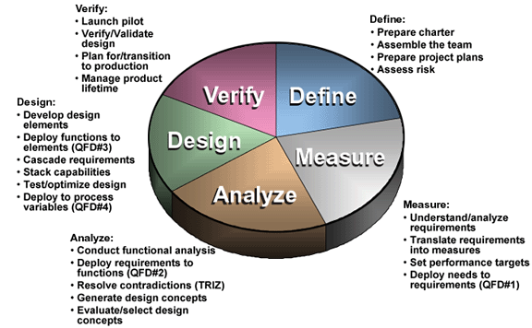

The acronym DMADV sounds pretty much similar to DMAIC. The similarity ends after the first three letters DMA

1. **Define**: You will define the goals of the project and that of the customers (both internal and external)

|  |  |
| --- | --- |
| **Goals** | * The purpose of this step is to clearly articulate the business problem, goal, potential resources, project scope and high-level project timeline. This information is typically captured within project charter document. Write down what you currently know. Seek to clarify facts set objectives and form the project team. Define the following: |
| **Output** | * + - A clear statement of the intended improvement and how it is to be measured     - A high-level map of the process     - A list of what is important to the customer |
| **Do** | * + - Define customer requirements as they relate to this project. Explicit customer requirements are called Critical-to-Quality (CTQ) characteristics;     - Develop defect definitions as precisely as possible;     - Perform a baseline study (a general measure of the level of performance before the improvement project commences)     - Create a team charter and Champion;     - Estimate the financial impact of the problem   Obtain senior management approval of the project |

1. **Measure**: Here you will quantify the customer needs as well as the goals of the management

|  |  |
| --- | --- |
| **Goals** | * The purpose of the Measure phase is to fully understand the current performance by identifying how to best measure current performance and to start measuring it. The measurements used should be useful and relevant to identifying and measuring the source of variation**.** Focus the improvement effort by gathering information on the current situation |
| **Output** | * + - Data that pinpoints problem location or occurrence     - Baseline data on current process sigma     - A more focused problem statement |
| **Do** | * + - Identify the specific performance requirements of relevant Critical-to-Quality (CTQ) characteristics     - Map relevant processes with identified Inputs and Outputs so that at each process step, the relevant Outputs and all the potential Inputs (X) that might impact each Output are connected to each other     - Generate list of potential measurements     - Analyze measurement system capability and establish process capability baseline     - Identify where errors in measurements can occur     - Start measuring the inputs, processes and outputs and collecting the data     - Validate that the problem exists based on the measurements     - Refine the problem or objective (from the Analysis phase) |

1. **Analyze**: Analyze the options, existing process to determine the cause of error origination and evaluate corrective measures

|  |  |
| --- | --- |
| **Goals** | * In the Analyze phase, the measurements collected in the Measure phase are analyzed so that hypotheses about the root causes of variations in the measurements can be generated and the hypothesis subsequently validated. It is at this stage that practical business problems are turned into statistical problems and analyzed as statistical problems |
| **Output** | * + - A theory that has been tested and confirmed |
| **Do** | * + - Generate hypotheses about possible root causes of variation and potential critical Inputs (X’s);     - Identify the vital few root causes and critical inputs that have the most significant impact     - Validate these hypotheses by performing Multivariate analysis. |

1. **Design**:

|  |  |
| --- | --- |
| **Goals** | * The purpose of this step design a new process or a corrective step to the existing one to eliminate the error origination that meets the target specification |
| **Output** | * New process is designed |
| **Do** | * Develop design elements * Deploy function to elements * Cascade requirement * Stack capabilities * Test/optimize design * Deploy to process variables |

1. **Verify**:

|  |  |
| --- | --- |
| **Goals** | * The purpose of this step is verify, by simulation or otherwise, the performance of thus developed design and its ability to meet the target needs |
| **Output** | Result of verify that the process designed works fine and is able to meet the target. Once the results are positive, the process is implemented and handed over to the customer. |
| **Do** | * Launch pilot * Verify/Validate design * Plan for/transition to production * Manage product lifetime |

* ***D****efine* (xác định) mục tiêu thiết kế nhằm phù hợp với yêu cầu của khách hàng và chiến lược của công ty.
* ***M****easure* (đo lường) và nhận ra CTQs (viết tắt của **C**ritical **T**o **Q**uality - giới hạn cho chất lượng), khả năng sản xuất, khả năng của dây truyền sản phẩm và những rủi ro.
* ***A****nalyze* (phân tích) nhằm phát triển và thiết kế những phương án khác.
* ***D****esign* (thiết kế) và nâng cao các phương án khác nhau, nhằm phù hợp nhất trong mỗi bước phân tích trước đó.
* ***V****erify* (xác nhận) thiết kế, chạy thử, áp dụng cho dây truyền sản xuất và bàn giao nó cho chủ sở hữu.

<http://www.cicsworld.org/blogs/kpanasoot/2009/12/six_sigma.html>

**How are DMAIC and DMADV Similar?**

* Six Sigma methodologies used to drive defects to less than 3.4 per million opportunities
* Data intensive solution approaches. Intuition has no place in Six Sigma
* Implemented by Green Belts, Black Belts, Master Black Belts
* Way to help meet the business / financial bottom-line number
* Implemented with the support of champion and process owner

**How are DMAIC and DMADV Different?**

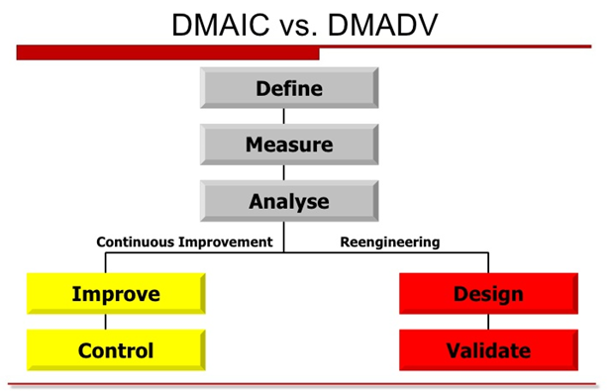

DMAIC concentrates on making improvements to a business process in order to reduce or eliminate defects; DMADV develops an appropriate business model destined to meet the customers’ requirements.

DMAIC tập trung vào việc cải thiện quy trình kinh doanh để giảm thiểu số defect còn DMADV tập trung phát triển mô hình kinh doanh phù hợp với yêu cầu của khách hàng

Despite the shared first three letters of their names, there are some notable differences between them.  The main difference exists in the way the final two steps of the process are handled.  With DMADV, the Design and Verify steps deal with redesigning a process to match customer needs, as opposed to the Improve and Control steps that focus on determining ways to readjust and control the process.   DMAIC typically defines a business process and how applicable it is; DMADV defines the needs of the customer as they relate to a service or product.

Sự khác biệt chính tồn tại trong cách hai bước cuối cùng của quy trình. Với DMADV, Design và Validate dùng để thiết kế lại một quá trình để phù hợp với nhu cầu khách hàng, còn DMAIC thì Improve và Control tập trung vào việc xác định cách làm thế nào để điều chỉnh và kiểm soát quy trình. DMAIC thường định nghĩa một quá trình kinh doanh và làm thế nào áp dụng nó là; DMADV xác định nhu cầu của khách hàng có liên quan đến một dịch vụ hoặc sản phẩm

With regards to measurement, DMAIC measures current performance of a process while DMADV measures customer specifications and needs.

Liên quan bước measurement DMAIC thường đo lường về hiệu suất hiện tại của một quy trình trong khi DMADV đo lường chi tiết kỹ thuật và nhu cầu của khách hàng.

**When Should DMAIC and DMADV Be Used?**

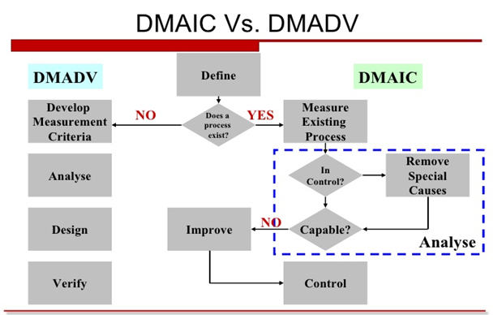

**When to use DMAIC**

Used when a product or process is in existence and is not meeting customer specification or is not performing adequately

**When to use DMADV**

A product or process is not existence and one needs to be developed

The existence product or process exist and has been optimized and still doesn’t meet the level of customer specification or six sigma level

<http://www.slideshare.net/anandsubramaniam/dmaic-vs-dmadv>

|  |  |
| --- | --- |
| **Project Phase** | **Six Sigma Tools** |
| **Define** | * **Project charter** this document is intended to clearly describe problems, defect definitions, team information and deliverables for a proposed project and to obtain agreement from key stakeholders. * **Trend Chart** - to see (visually) the trend of defect occurrence over a period of time. * **VOC tools (surveys, focus groups, letters, comment cards)** * **Process map** * **QFD** * **SIPOC** * **Benchmarking** * **Project planning and management tools** * **Pareto analysis** to see (visually) how critical each input is in contributing negatively or positively to total output or defects. |
| **Measure** | * **Fishbone Diagram** – to demonstrate the relationships between inputs and outputs * **Process Mapping** - to understand the current processes and enable the team to define the hidden causes of waste. * **Cause & Effect Matrix** - to quantify how significant each input is for causing variation of outputs. * **Preliminary Failure Mode & Effect Analysis (FMEA)** - using this in the Measure phase helps to identify and implement obvious fixes in order to reduce defects and save costs as soon as possible. * **Gauge Repeatability & Reproducibility (GR&R**) - used to analyze the variation of components of measurement systems so minimize any unreliability in the measurement systems. |
| **Analyze** | * **Five Why’s** - use this tool to understand the root causes of defects in a process or product, and to penetrate through incorrect assumptions about causes. * **Tests for normality (Descriptive Statistics, Histograms**) – this is used to determine if the collected data is normal or abnormal so as to be properly analyzed by other tools. * **Correlation/Regression Analysis** - to identify the relationship between process inputs and outputs or the correlation between two different sets of variables. * **Analysis of Variances (ANOVA)** - this is an inferential statistical technique designed to test for significance of the differences among two or more sample means. * **FMEA (Failure Mode and Effect Analysis**) - applying this tool on current processes enables identification of sufficient improvement actions to prevent defects from occurring. * **Hypothesis testing methods** - these are series of tests in order to identify sources of variability using historical or current data and to provide objective solutions to questions which are traditionally answered subjectively. |
| **Improve** | * + - Force field diagrams     - FMEA     - 7M tools     - Project planning and management tools     - Prototype and pilot studies     - Simulations     - Process Mapping - this tool helps to represent the new process subsequent to the improvements.     - Process Capability Analysis (CPK) - in order to test the capability of process after improvement actions have been implemented to ensure we have obtained a real improvement in preventing defects.     - DOE (Design of Experiment) - This is a planned set of tests to define the optimum settings to obtain the desired output and validate improvements. |
| **Control** | * Control Plans -t his is a single document or set of documents that documents the actions, including schedules and responsibilities, that are needed to control the key process inputs variables at the optimal settings. * Operating Flow Chart(s) with Control Points - this is a single chart or series of charts that visually display the new operating processes. * Statistical Process Control (SPC) charts - these are charts that help to track processes by plotting data over time between lower and upper specification limits with a center line. * Check Sheets - this tool enables systematic recording and compilation of data from historical sources, or observations as they happen, so that patterns and trends can be clearly detected and shown. |

|  |  |
| --- | --- |
| **Project Phase** | **Candidate Six Sigma Tools** |
| **Define** | * Project charter * VOC tools (surveys, focus groups, letters, comment cards) * Process map * QFD * SIPOC * Benchmarking * Project planning and management tools * Pareto analysis |
| **Measure** | * Measurement systems analysis * Process behavior charts (SPC) * Exploratory data analysis * Descriptive statistics * Data mining * Run charts * Pareto analysis |
| **Analyze** | * Cause-and-effect diagrams * Tree diagrams * Brainstorming * Process behavior charts (SPC) * Process maps * Design of experiments * Enumerative statistics (hypothesis tests) * Inferential statistics (Xs and Ys) * Simulation |
| **Improve** | * Force field diagrams * FMEA * 7M tools * Project planning and management tools * Prototype and pilot studies * Simulations |
| **Control** | * SPC * FMEA * ISO 900× * Change budgets, bid models, cost estimating models * Reporting system |